**DITCHLING PARISH COUNCIL**

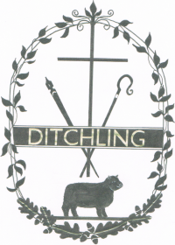

**Ditchling Parish Council Grant Applications for 2023/2024**

The Parish Council has the sum of £2,000 in its 2023/24 budget allocated to grants.

Applications will be considered at the December Parish Council Meeting to be held on the 11th December 2023 from 7.30pm in Ditchling Village Hall, lower hall.

If your organisation would like to apply for a grant, please read the Parish Council Grants Policy our website. Application forms are available here too or you are welcome to apply to the Parish Clerk for an application form at [parishoffice@ditchling-pc.gov.uk](mailto:parishoffice@ditchling-pc.gov.uk) or by calling 01273 844733.

All applications are required to be received by the 1st December 2023 so the Council can consider applications at the December Parish Council Meeting before making a decision on allocation of funds available.

If you have any further queries in relation to an application, please contact the Parish Clerk.

Thank you

Clerk :- Julia Shelley

Parish Council Office;- 01273 844733

Mobile :- 07730 001130

E-mail:-parishoffice@ditchling-pc.gov.uk

Website:-[www.ditchlingpc.org.uk](http://www.ditchlingpc.org.uk)

.